Order Of Lenten Service

Opening Hymn: TLH 153

Reading: Lent V

The History of the Passion of our Lord

Sermon Hymn: TLH 376

Sermon Text: Song Of Solomon 2:14

The Clefts of The Rock

Prayer

Holy Communion

The Lord's Prayer

The Blessing

Closing Hymn: TLH 156

* * * * * * * * * * * * *

Koinonia Hour

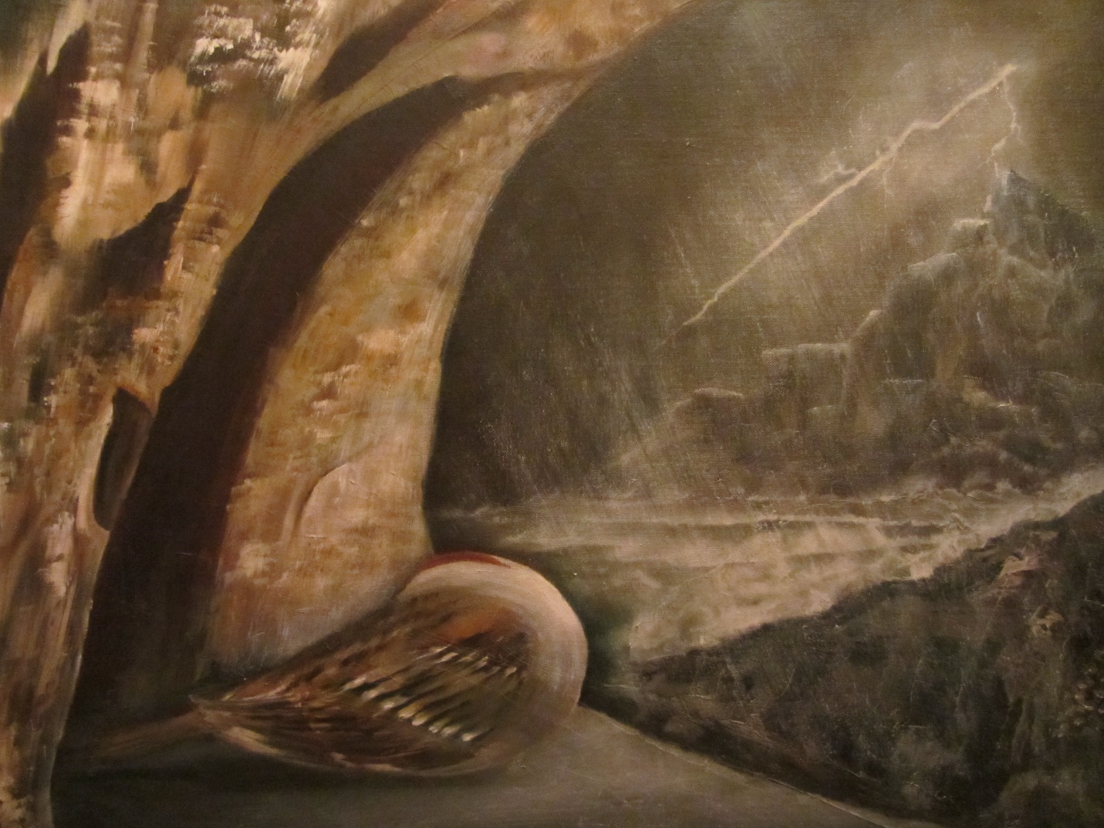

Perfect Peace

Water
Of
Life

6 March 2016

W A T E R O F L I F E

Independent Christian Church—Conservative Lutheran Doctrine

Worship Service: 9:30 a.m. Bible Study: 10:45 a.m.

Larry Cooper, Pastor E-Mail address:
111 N. Ridge Road lcooper@wateroflife.cc
Coon Valley, WI 54623 Web Site:
Phone: (608) 452-2105 www.wateroflife.cc

* * * * * * * * * * * * * * * * * * * * * * * * * * *

Sermon Text: Song Of Solomon 2:14

The Clefts of The Rock

* * * * * * * * * * * * * * * * * * * * * * * * * * *

Song of Solomon 2:14 O my dove, that art in the clefts of the rock, in the secret places of the stairs, let me see thy countenance, let me hear thy voice; for sweet is thy voice, and thy countenance is comely.

Here in verse 14 we have a change of scenery. The Holy Spirit speaks of a dove that is in the clefts of The Rock.

The Bride of Christ is often compared in Scripture to a dove. For one example, in Psalm 68:13 the Spirit tells us—“Though ye have lien among the pots, yet shall ye be as the wings of a dove covered with silver, and her feathers with yellow gold.”
Here in Song Of Songs the dove is pictured as being “In the clefts of The Rock.”

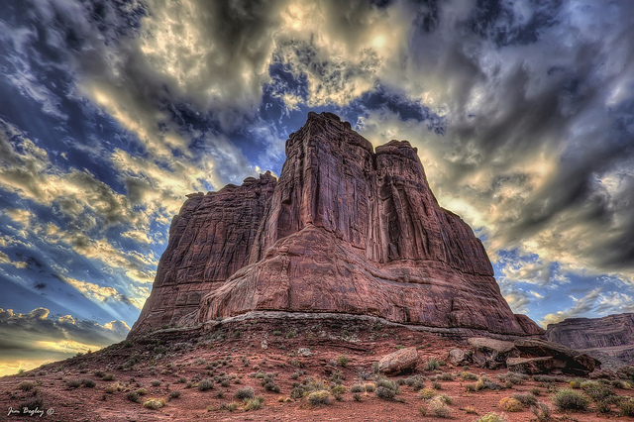

Often in Scripture the Son of God is compared to a rock. In Psalm 18:2 we read—“The Lord is my rock, and my fortress, and my deliverer; my God, my strength, in whom I will trust; my buckler, and the horn of my salvation, and my high tower.”

And again in his Sermon on the Mount the Lord says—“Therefore whosoever heareth these sayings of mine, and doeth them, I will liken him unto a wise man, which built his house upon a rock. And the rain descended, and the floods came, and the winds blew, and beat upon that house; and it fell not: for it was founded upon a rock.”

So the dove which is in the clefts of the Rock is safe and protected from the wind and the waves that threaten her.

